**Answers to week 2 assignment 2**

**1. Installation of VS Code:**

**- Describe the steps to download and install Visual Studio Code on Windows 11 operating system. Include any prerequisites that might be needed.**

### **Installation of VS Code on Windows 11**

#### **Prerequisites:**

* Windows 11 operating system
* Administrator privileges on your machine

#### **Steps to Download and Install Visual Studio Code:**

1. **Download VS Code**:
   * Go to the [Visual Studio Code website](https://code.visualstudio.com/).
   * Click on the download button for Windows.
2. **Run the Installer**:
   * Locate the downloaded setup file (VSCodeSetup-x.x.x.exe) in your Downloads folder and double-click to run it.
3. **Accept License Agreement**:
   * Read the license agreement, then click the checkbox to accept the terms and click Next.
4. **Select Installation Location**:
   * Choose the destination folder for the installation or keep the default path, then click Next.
5. **Select Additional Tasks**:
   * Check the boxes for additional tasks like creating a desktop icon and adding "Open with Code" action to the context menu, then click Next.
6. **Install**:
   * Click Install to begin the installation process. Once the installation is complete, click Finish.
7. **Launch VS Code**:
   * After installation, VS Code should launch automatically. If not, open it from the Start menu or desktop shortcut.

**2. First-time Setup:**

**- After installing VS Code, what initial configurations and settings should be adjusted for an optimal coding environment? Mention any important settings or extensions.**

### **First-time Setup**

#### **Initial Configurations and Settings:**

1. **Theme**:
   * Open the Command Palette (Ctrl+Shift+P), type Theme, and select Preferences: Color Theme. Choose your preferred theme.
2. **Font Size**:
   * Go to File > Preferences > Settings or press Ctrl+,.
   * Search for font size and adjust the Editor: Font Size setting.
3. **Extensions**:
   * Open the Extensions view by clicking the Extensions icon in the Activity Bar or pressing Ctrl+Shift+X.
   * Search for and install essential extensions like:
     + **Prettier**: Code formatter
     + **ESLint**: Linting
     + **GitLens**: Git supercharged
     + **Python**: For Python development
     + **Live Server**: For live-reloading during web development
4. **Auto Save**:
   * In Settings, search for auto save and set Files: Auto Save to afterDelay or onFocusChange.
5. **Workspace Settings**:
   * Open File > Add Folder to Workspace and add your project folder. This allows you to customize settings specific to the project.

**3. User Interface Overview:**

**- Explain the main components of the VS Code user interface. Identify and describe the purpose of the Activity Bar, Side Bar, Editor Group, and Status Bar.**

### **User Interface Overview**

#### **Main Components of VS Code UI:**

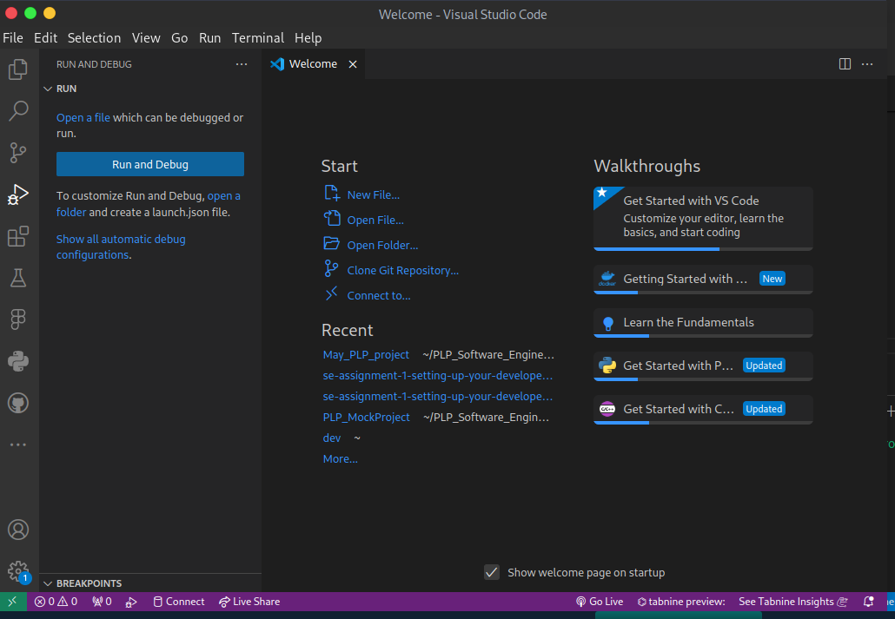

1. **Activity Bar**:
   * Located on the far left, it allows you to switch between views like Explorer, Search, Source Control, Run and Debug, and Extensions.
2. **Side Bar**:
   * Displays different views depending on the selected activity (e.g., file explorer, search results, Git changes).
3. **Editor Group**:
   * The main area where you edit your files. You can open multiple files in tabs and split the editor into multiple panes.
4. **Status Bar**:
   * Located at the bottom, it provides information about the current project and file, such as language mode, encoding, line and column numbers, and Git branch.

**4. Command Palette:**

**- What is the Command Palette in VS Code, and how can it be accessed? Provide examples of common tasks that can be performed using the Command Palette.**

### **Command Palette**

#### **What is the Command Palette?**

The Command Palette is a powerful tool in VS Code that provides access to various commands and features. It can be accessed by pressing Ctrl+Shift+P (or F1).

#### **Examples of Common Tasks:**

* **Opening Settings**:
  + Type Settings and select Preferences: Open Settings (UI).
* **Changing Theme**:
  + Type Theme and select Preferences: Color Theme.
* **Running Tasks**:
  + Type Task and select Tasks: Run Task.
* **Git Commands**:
  + Type Git and choose from commands like Git: Clone, Git: Commit, Git: Push.

**5. Extensions in VS Code:**

**- Discuss the role of extensions in VS Code. How can users find, install, and manage extensions? Provide examples of essential extensions for web development.**

### **Extensions in VS Code**

#### **Role of Extensions:**

Extensions enhance the functionality of VS Code by adding features such as language support, debuggers, linters, and more.

#### **Finding, Installing, and Managing Extensions:**

1. **Finding Extensions**:
   * Open the Extensions view by clicking the Extensions icon in the Activity Bar or pressing Ctrl+Shift+X.
   * Use the search bar to find extensions.
2. **Installing Extensions**:
   * Click the Install button next to the desired extension.
3. **Managing Extensions**:
   * Installed extensions can be managed from the Extensions view. You can disable, enable, or uninstall extensions as needed.

#### **Examples of Essential Extensions for Web Development:**

* **Prettier**: Code formatter
* **ESLint**: Linting
* **Live Server**: Live reload
* **Debugger for Chrome**: Debugging
* **HTML Snippets**: HTML code snippets

**6. Integrated Terminal:**

**- Describe how to open and use the integrated terminal in VS Code. What are the advantages of using the integrated terminal compared to an external terminal?**

### **Integrated Terminal**

#### **Opening and Using the Integrated Terminal:**

1. **Opening the Terminal**:
   * Open the terminal by pressing Ctrl+`` or selecting View > Terminal` from the menu.
2. **Using the Terminal**:
   * The integrated terminal allows you to run command-line tools and scripts without leaving VS Code.

#### **Advantages of Using the Integrated Terminal:**

* **Convenience**: No need to switch between VS Code and an external terminal.
* **Project Context**: The terminal starts in the workspace folder, making it easy to run commands in the right context.
* **Multiple Terminals**: You can open multiple terminal instances and switch between them.

**7. File and Folder Management:**

**- Explain how to create, open, and manage files and folders in VS Code. How can users navigate between different files and directories efficiently?**



### **File and Folder Management**

#### **Creating, Opening, and Managing Files and Folders:**

1. **Creating Files and Folders**:
   * Right-click in the Explorer view and select New File or New Folder.
   * Use the File menu to create new files (File > New File) or folders (File > New Folder).
2. **Opening Files and Folders**:
   * Drag and drop files/folders into VS Code.
   * Use File > Open File or File > Open Folder to open files and folders.
3. **Navigating Between Files**:
   * Use the Explorer view to browse files.
   * Press Ctrl+P to open the Quick Open dialog and type the name of the file you want to open.

#### **Efficient Navigation:**

* **Go to Definition**: F12 or right-click and select Go to Definition.
* **Go to File**: Ctrl+P.
* **Breadcrumbs**: Enable breadcrumbs (View > Toggle Breadcrumbs) to navigate through the file structure.

**8. Settings and Preferences:**

**- Where can users find and customize settings in VS Code? Provide examples of how to change the theme, font size, and keybindings**.

### **ettings and Preferences**

#### **Customizing Settings:**

1. **Accessing Settings**:
   * Go to File > Preferences > Settings or press Ctrl+,.
2. **Changing Theme**:
   * In Settings, search for Color Theme and select your preferred theme.
3. **Adjusting Font Size**:
   * Search for font size and adjust the Editor: Font Size setting.
4. **Customizing Keybindings**:
   * Go to File > Preferences > Keyboard Shortcuts or press Ctrl+K Ctrl+S to view and customize keybindings

**9. Debugging in VS Code:**

**- Outline the steps to set up and start debugging a simple program in VS Code. What are some key debugging features available in VS Code?**

### **Debugging in VS Code**

#### **Setting Up and Starting Debugging:**

1. **Open the Debug View**:
   * Click the Debug icon in the Activity Bar or press Ctrl+Shift+D.
2. **Configure the Debugger**:
   * Click create a launch.json file to add a new debugger configuration. Select the appropriate environment (e.g., Node.js, Python).
3. **Set Breakpoints**:
   * Click in the gutter next to the line number where you want to set a breakpoint.
4. **Start Debugging**:
   * Click the green play button in the Debug view or press F5.

#### **Key Debugging Features:**

* **Breakpoints**: Pause execution at specific lines.
* **Step Over/Into**: Control execution flow.
* **Variables**: Inspect variable values.
* **Watch**: Monitor specific expressions.
* **Call Stack**: View the call stack at any point.

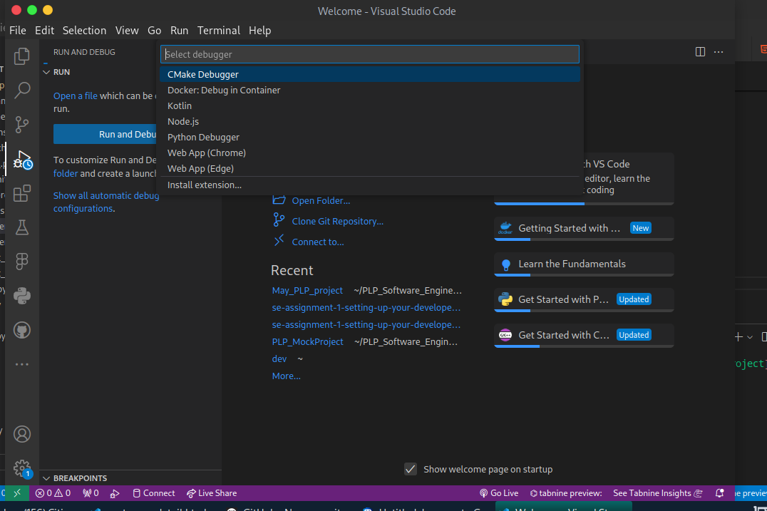

**10. Using Source Control:**

**- How can users integrate Git with VS Code for version control? Describe the process of initializing a repository, making commits, and pushing changes to GitHub.**

### **Using Source Control**

#### **Integrating Git with VS Code:**

**Initialize a Repository**:

* + Open the Source Control view by clicking the Source Control icon in the Activity Bar or pressing Ctrl+Shift+G.
  + Click Initialize Repository if starting from scratch.

**Making Commits**:

* + Stage changes by clicking the + next to the file in the Source Control view.
  + Enter a commit message and click the checkmark to commit.

**Pushing Changes to GitHub**:**Set Up Remote**:  
  
git remote add origin https://github.com/username/repository.git

**Push Changes**:  
  
git push -u origin main

**Additional Git Commands**:

**Pull Changes**:  
git pull origin main

**Create Branch**:  
  
git checkout -

